**Website Planning Document**

Weather’s Story

Author: Mackenzie B. Lee

**Site Purpose**

The purpose of “Weather’s Story” is to tell not only the stories of the cities of Franklin, Greenville, and Springfield; but to also bring forward the current weather of the three cities mentioned.

**Target Audience**

The target audience is busy college students that are not into planning for the weather of the current cities “Weather’s Story” provides.

**Persona:**



* + **Name**: John Doe
  + **Occupation**: College Student
  + **Age**: 21
  + **Interests**: Traveling, Flying, Play acting, Eating
  + **Motivation**: John is not into planning. His last-minute scrambling, whether it is getting to his play-acting class in the morning or heading out on his latest adventure, has left him unprepared for weather conditions many times. He is tired of sleeping in the rain and snow. He would like to be more prepared without having to put much effort into it or planning in general.
  + **Environment**: John is comfortable using laptops and mobile devices, he will most often be found on a smart phone. However, many of the places he frequents do not have great signal.

**Site Map**

Home

Franklin Greenville Springfield Storm Center Gallery

Franklin City Greenville City Springfield City Weather Information Photos of Locations

**Color Scheme**

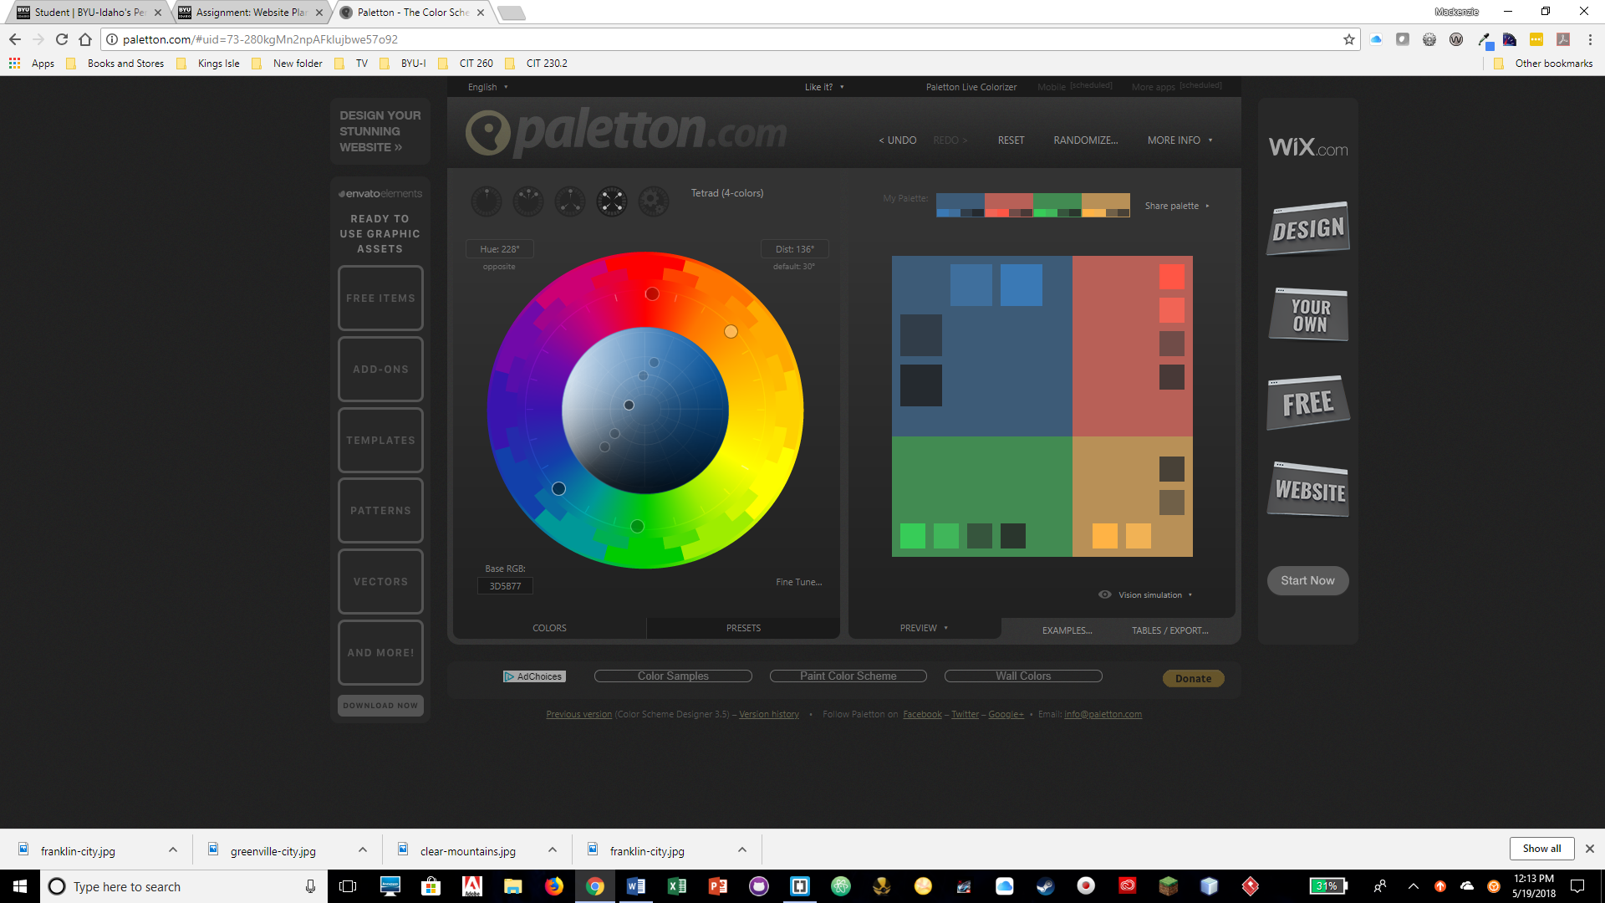

Background for Top Footer and Navigation: Light Blue- #3A79B5

Background for Bottom Footer: Darker Blue- #3D5A77

Body text: Black- #000000

**Typography**

Heading Font: Abril Fatface

@import url('https://fonts.googleapis.com/css?family=**Abril+Fatface**');

<link href="https://fonts.googleapis.com/css?family=**Abril+Fatface**" rel="stylesheet">

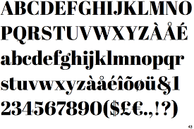

Body Font: Karla

@import url('https://fonts.googleapis.com/css?family=**Karla**');

<link href="https://fonts.googleapis.com/css?family=**Karla**" rel="stylesheet">

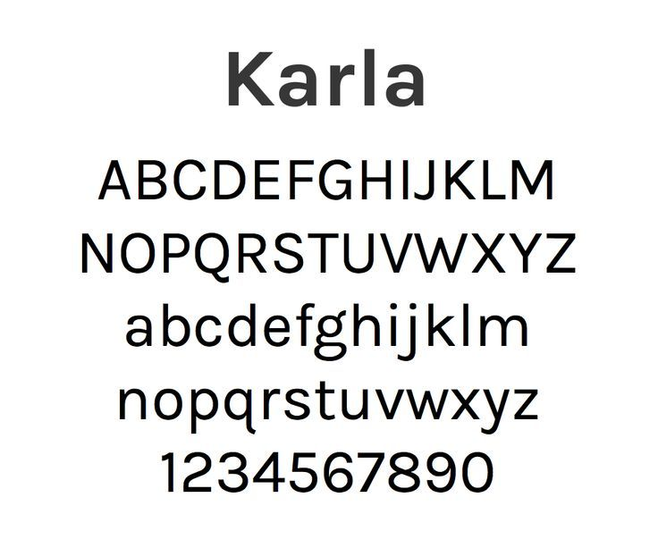

**Wire-Frame Sketches**

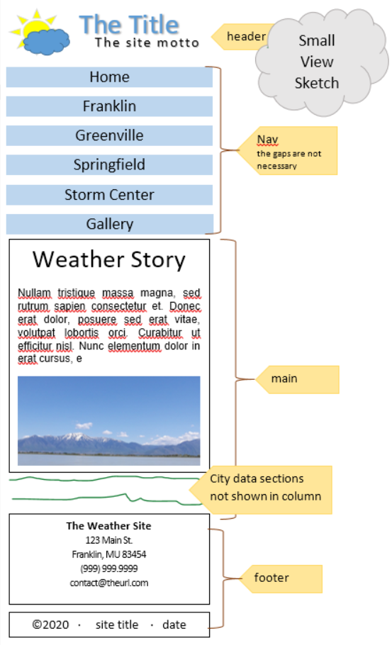

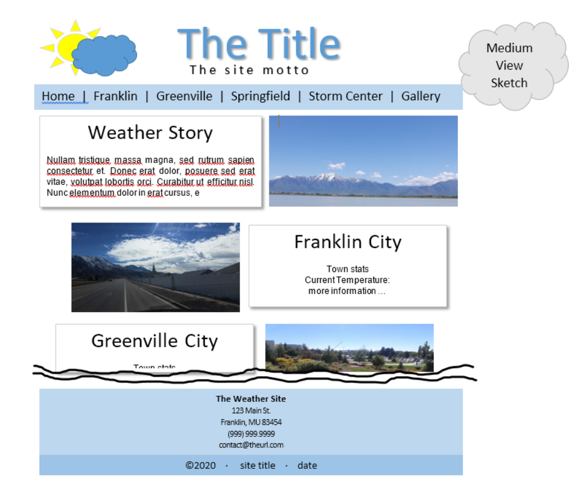

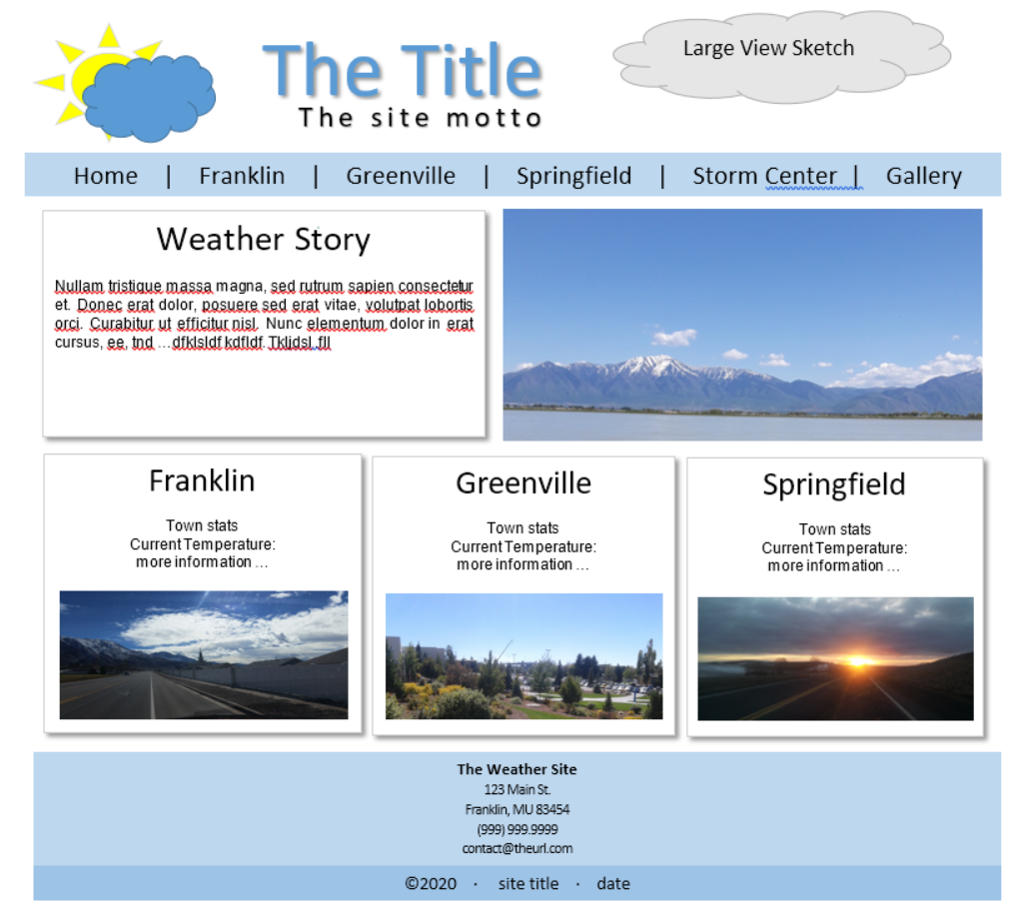

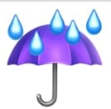Weather’s Story

Preview of City Page

Providing the best weather service.

|  |
| --- |
| Home | Franklin | Greenville | Springfield | Storm Center | Gallery |

**Franklin City, Franklin**

**Zip:** "83237" | **Elevation:** "4501 ft." | **Location:** "42.0135°N, 111.8072°W"

**Current Temperature**

25 F

High: 34 Low: 10

**Town Stats**

**Current Population:** 30,000

**Zip Codes:** 82230, 82337, 83237.

&copy will be the copyright symbol

JavaScript

Wind dial may move depending on current wind condintions

No Border



**Current wind speed**



S

&copy 2020 . site title . date

**Weather's Story**

123 Main St.

Franklin, MU 83454

(999) 999-9999

<p>contact@theurl.com</p>